**AIT-524, Class 13, Practice Problems**

**Tanmoy Chowdhury, G01025893**

### Practice Problems:

**Questions:**

1. **List the book title and retail price for all books with a retail price lower than the average retail price of all books sold by JustLee Books**

**My Note: group function is not allowed here" in where statement. That is why single-row subquery used.**

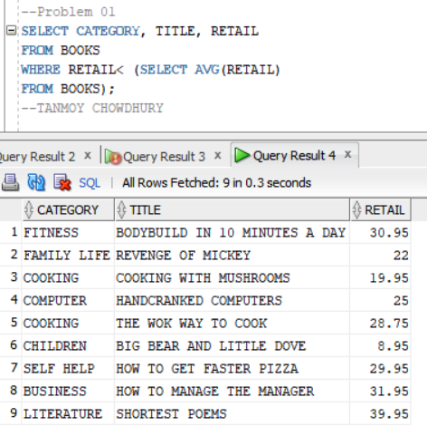

1. **Determine which books cost less than the average cost of other books in the same category..**

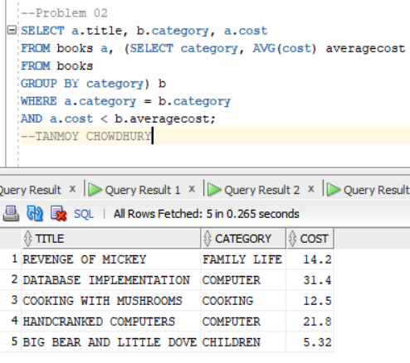

1. **Determine which orders were shipped to the same state as order 1014.**

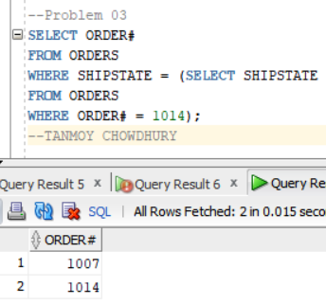

1. **Determine which orders had a higher total amount due than order 1008**

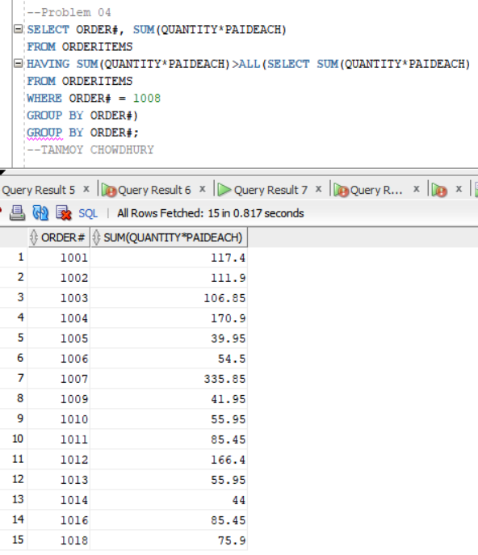

1. **Determine which author or authors wrote the books most frequently purchased by customers of JustLee Books.**

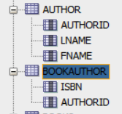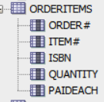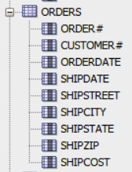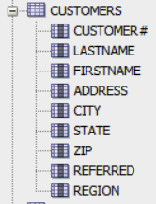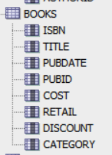

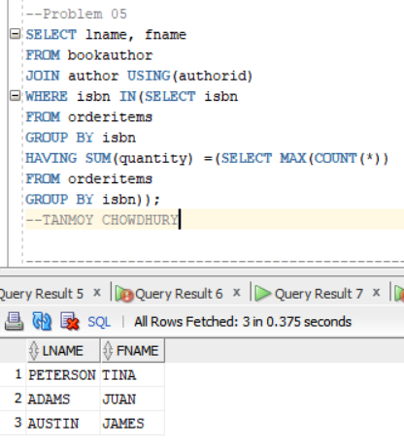

1. **.List the title of all books in the same category as books previously purchased by customer 1007. Don’t include books this customer has already purchased.**



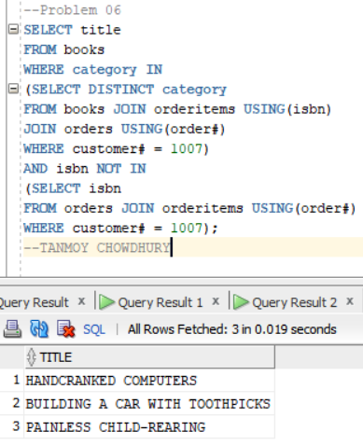

1. **List the shipping city and state for the order that had the longest shipping delay.**

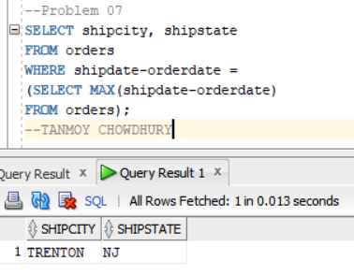

1. **Determine which customers placed orders for the least expensive book (in terms of regular retail price) carried by JustLee Books.**

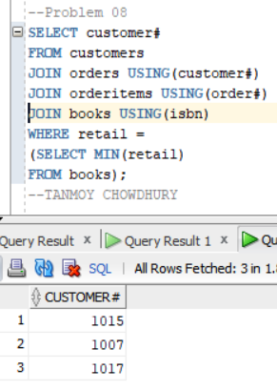

1. **Determine the number of different customers who have placed an order for books written or  
   cowritten by James Austin.**



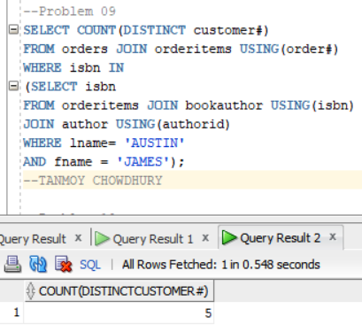

1. **Determine which books were published by the publisher of The Wok Way to Cook**

